Our Eco Code
We care about the envronment and we strive to:

Reduce waste by recycling whenever we can.

Save energy by switching things off.

Keep our school clean and tidy.

Improve our school grounds.
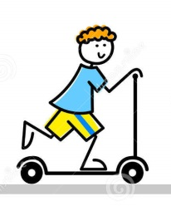
Try to travel in environmentally friendly ways.

Encourage people to be healthy and active at school and at home.

